Unit 2 Exam Revision Part 1

Outdoor  Environment | Example of  Specific Location  within Victoria | Rainfall | Common Fauna | Common Flora

Biotic | Abiotic

Abiotic Cycles
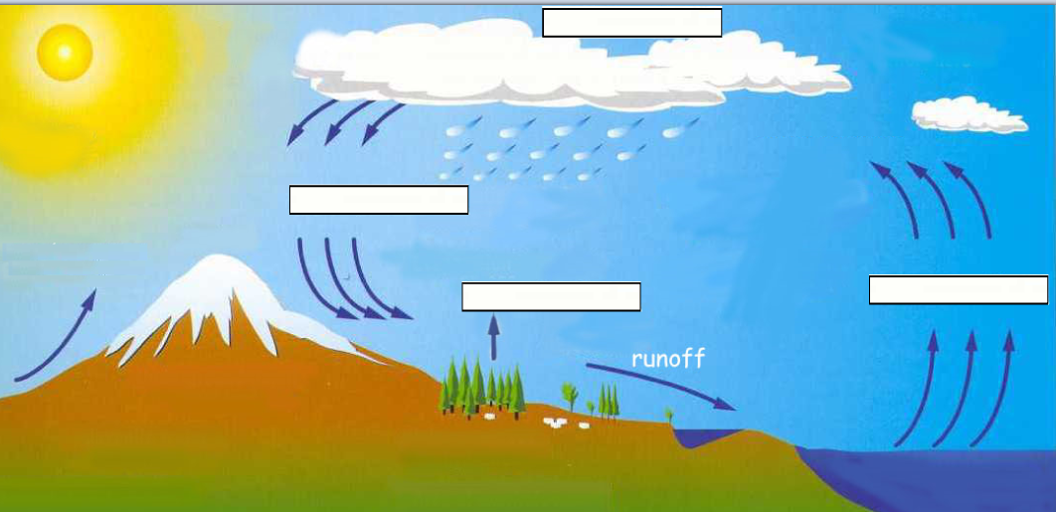
What Cycle is it?
Explain what is occurring here? ______________________________________________________________________________________________________________________________________________________________________________________________
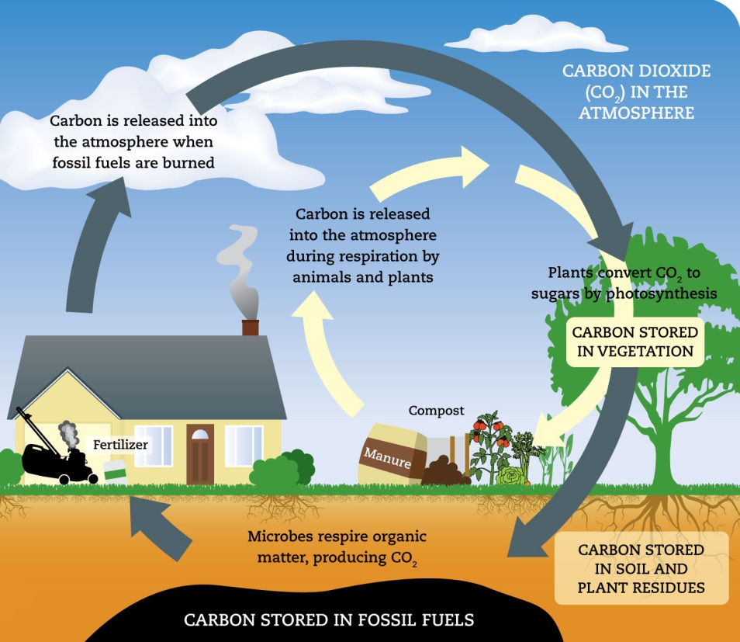
Using this Diagram Explain the Carbon Cycle
_____________________________________
_____________________________________
_____________________________________
_____________________________________
_____________________________________
_____________________________________
_____________________________________
_____________________________________

Discuss where a Biotic and Abiotic component would have an interaction together in a natural environment.
_____________________________________________________________________________________________________________________________________________________________________________________________________________________________________________________________________________________________

Natural Changes
Natural Change | Effect on the Environment | Effect on your participation within that environment | Short or Long Term

What is an Indigenous activity which altered the natural environment?
________________________________________________________________
What are some of the ways the natural environment was altered as a result of this activity?
- ________________________________________________________________
- ________________________________________________________________
- ________________________________________________________________
- ________________________________________________________________

