VCE OUTDOOR & ENVIRONMENTAL STUDIES

OS033 Head Start Booklet
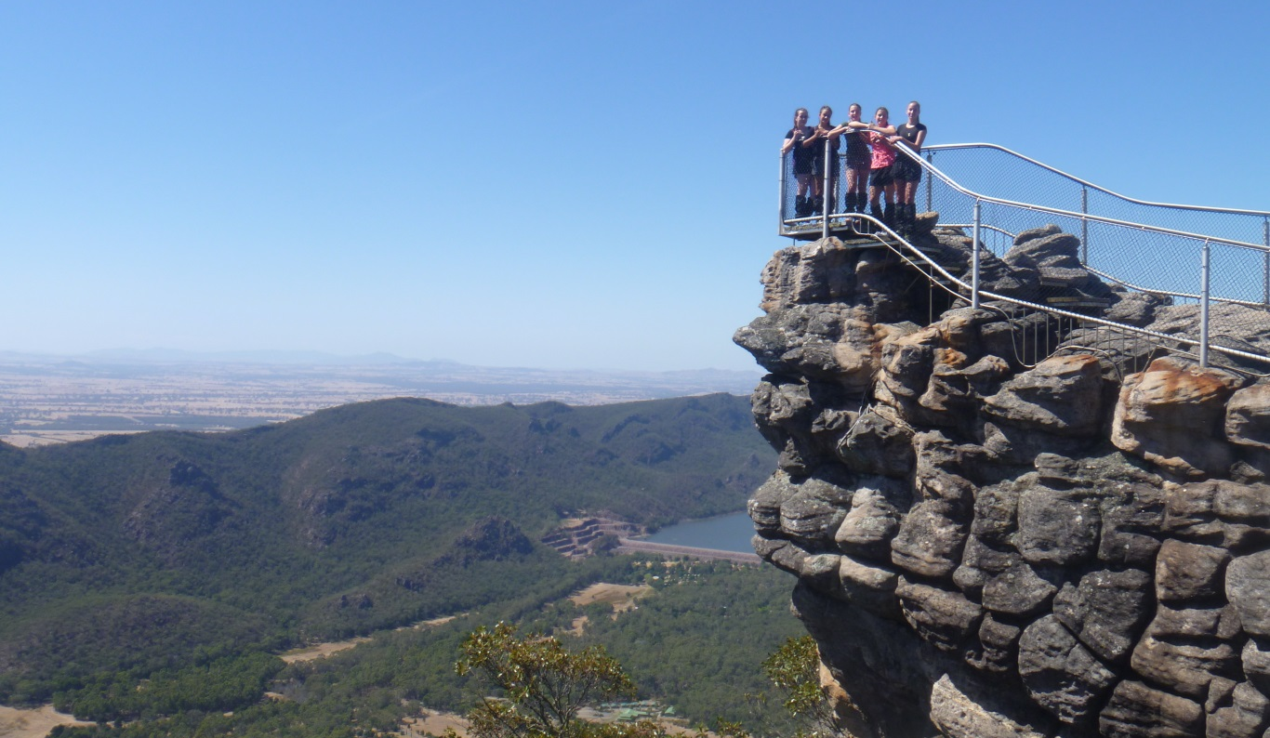
2015

WHAT’S YOUR GOAL?

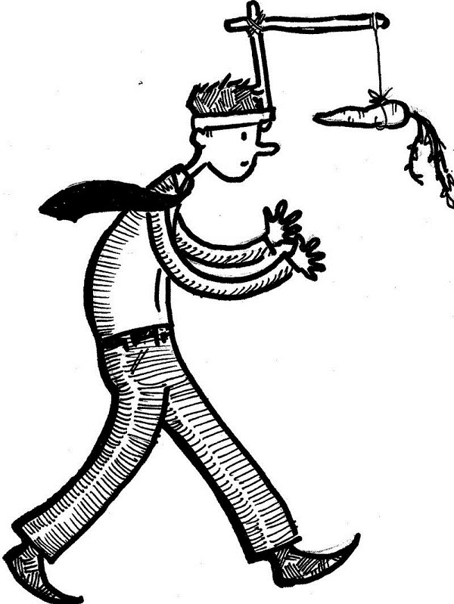

Goal (ATAR, Study score, experiences, knowledge?)

From OES in 2015 I want to.. ____________________________________________________________________________________________________________________________________________________________________________________________________________________________________________________________________________________________________________________________________

Unit 3: Relationships with Outdoor Environments

Area of Study 1: Historical Relationships with Outdoor Environments

1 - An overview of Australian outdoor environments before humans, including characteristics of biological isolation, geological stability and climatic variations

2 - Relationships with Australian environments expressed by specific Indigenous communities before and after European colonisation.

3 - Relationships with Australian outdoor environments as influenced by:
- The first non-Indigenous settlers' experiences
- Increasing population
- Industrialisation
- Nation Building

4 - The foundation and role of environmental movements in changing relationships with outdoor environments in relation to:
- The Wilderness Society
- Australian Conservation Foundation
- Victorian National Parks Association
- Greenpeace
- Gould League

Area of Study 2: Contemporary Relationships with Outdoor Environments
1 - Contemporary societal relationships with outdoor environments reflected in different forms of conservation, recreation, primary industries, and tourism practices
2 - The factors influencing contemporary societal relationships with outdoor environments, including:
- the effects of different technologies
- commercialisation of outdoor environments and outdoor experiences
- portrayals of outdoor environments and outdoor experiences in the media, music, art, writing and advertising
- social responses to risk taking
- social and political discourses about climate change, water management, biosecurity and other contemporary environmental issues

Unit 4: Sustainable Outdoor Relationships
Area of Study 1: Healthy Outdoor Environments

1 - Understandings and critiques of sustainability and sustainable development

2 - Indicators of healthy outdoor environments, including:
- Quality and adequacy of water, air and soil
- Levels of biodiversity, pest and introduced species

3 - The contemporary state of outdoor environments in Australia with reference to common themes used in the State of the Environment Reports

4 - The potential impact on society and outdoor environments of (a) Land degradation; (b) Introduced species; (c) Climate change; (d) Urbanisation and other significant threats

5 - The importance of healthy outdoor environments for individual physical and emotional wellbeing, and for the future of society

Area of Study 2: Sustainable Outdoor Environments

1 - At least two conflicts of interest between people involved in uses of outdoor environments, including at least one from the following:
- Marine national parks and sanctuaries (Victoria)
- Franklin river campaign (Tasmania)
- Grazing in the Alpine National Park (Victoria)
- Desalination plant at Wonthaggi (Victoria)

2 - The methods used by individuals and groups to influence decisions about the use of outdoor environments

3 - The decision-making processes followed by land managers and/or governments or their agencies relating to conflicting interests over the use of outdoor environments, including the role of the Victorian Environment Assessment Council (VEAC)

4 - Management strategies and policies for achieving and maintaining healthy and sustainable outdoor environments that may be adopted by public and private land managers, including at least one from the following:
- Trust for nature (Victoria)
- Australia's Biodiversity Conservation Strategy 2010-2020
- Victoria's Native Vegetation Management: A framework for action

5 - At least two acts or conventions related to the management and sustainability of outdoor environments, including at least one from the following:
- Flora and Fauna Guarantee Act 1988 (Vic)
- Environment Protection and Biodiversity Conservation Act 1999 (Commonwealth)
- RAMSAR Convention (International treaty, 1971)

6 - Actions undertaken to sustain healthy outdoor environments, including at least two of the following:
- green building design,
- integrated farming,
- urban planning,
- renewable energy
- Landcare

HOW YOUR MARKS ARE CALCULATED

UNIT 3

SAC 1 (50 marks) – 12.5%
SAC 2 (50 marks) – 12.5%

School-assessed Coursework for Unit 3 contributes 25 per cent.

UNIT 4

SAC 1 (40 marks) – 10%
SAC 2 (30 marks) – 7.5%
SAC 3 (30 marks) – 7.5%
School-assessed Coursework for Unit 4 contributes 25 per cent.
END OF YEAR EXAMINATION

Description
The examination will be set by a panel appointed by the Victorian Curriculum and Assessment Authority. All the key knowledge and key skills that underpin the outcomes in Units 3 and 4 are examinable.

Conditions
The examination will be completed under the following conditions:
● Duration: Two hours plus 15 minutes reading time.
● Victorian Curriculum and Assessment Authority examination rules will apply.
● The examination will be marked by assessors appointed by the Victorian Curriculum and Assessment Authority.
The End of year examination will contribute 50 per cent.

 | Term 1 | Term 2 | Term 3 | Term 4
Topics | Historical relationships with outdoor environments | Contemporary relationships with outdoor environments | Healthy outdoor environments | Revision
 | Contemporary relationships with outdoor environments | Healthy outdoor environments | Sustainable outdoor environments | Revision
Assessments | SAC 1 – 50% of Unit 3 | Sac 2 – 50% of Unit 3 | Sac 3 – 40% of Unit 4 | End of Year Examination (October/ November)
 |  |  | Sac 4- 30% of Unit 4
 |  |  | Sac 5 – 30% of Unit 4
Excursions | 3 day - Grampians National Park and Brambuk Cultural Centre | 1 Day trip TBC | 3 day - Murray River Paddle

Unit 3: Relationships with Outdoor Environments
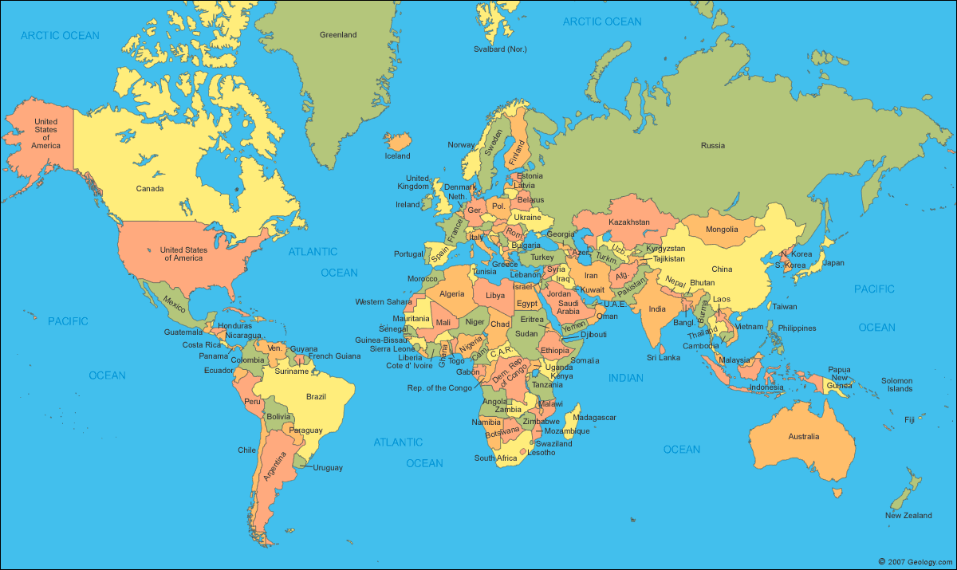
3.1.1 - an overview of Australian outdoor environments before humans, including characteristics of biological isolation, geological stability, and climatic variations.
Above is a map of the world, as it exists today.
- Do you think that the world always looked like this? Why / Why not?
_________________________________________________________________________________
_________________________________________________________________________________
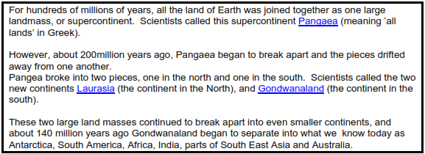
To get you thinking…
- If Antarctica, South America, Africa, India, parts of South East Asia and Australia were at one point joined together, what impact would this have had on the flora and fauna after this period?

_______________________________________________________________________________________________________________________________________________________________________________________________________________________________________________________________________________________________________________________________________________________________________________________

- What evidence do we have that the break-up of all these continents had an impact on the flora and fauna?
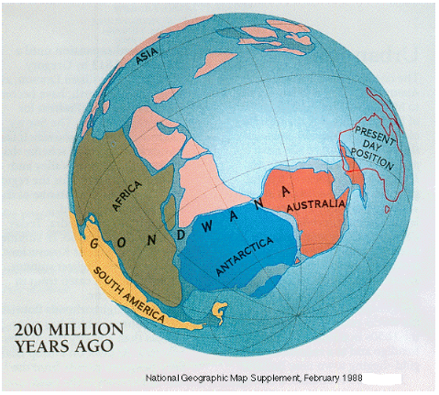
____________________________________________________________________________________________________________________________________________________________________________________________________________________________________________________________________________________________________________

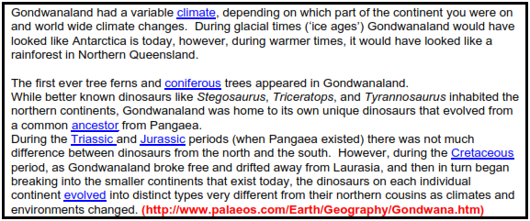
- How do we know of the existence of Pangaea, Laurasia and Gondwanaland? What types of ‘clues’ could exist in our modern world that might suggest the existence of the supercontinents?

_________________________________________________________________________________
_________________________________________________________________________________
_________________________________________________________________________________
_________________________________________________________________________________

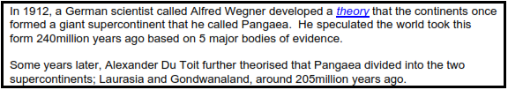

- What is the meaning of the word ‘Theory’?
_________________________________________________________________________________
_________________________________________________________________________________

- How would he have supported his theory, or prove if it is true?
_________________________________________________________________________________
_________________________________________________________________________________

PANGAEA

Gondwanaland (Australia) Laurasia

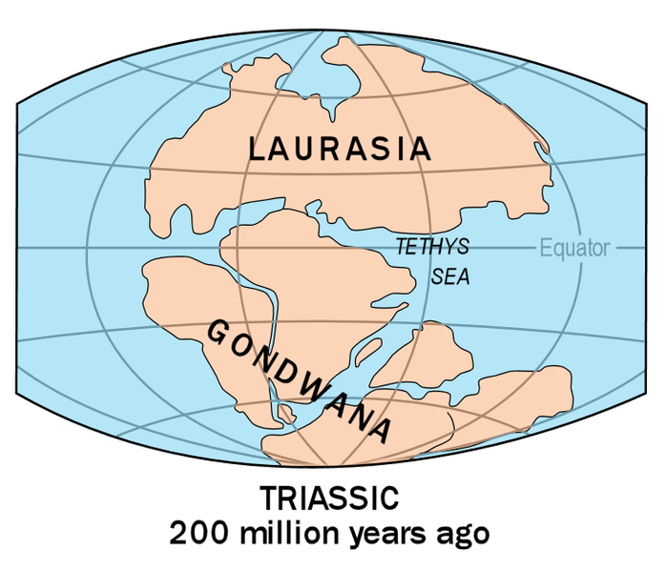

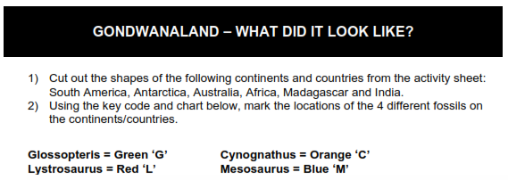
Flora and Fauna of Gondwanaland
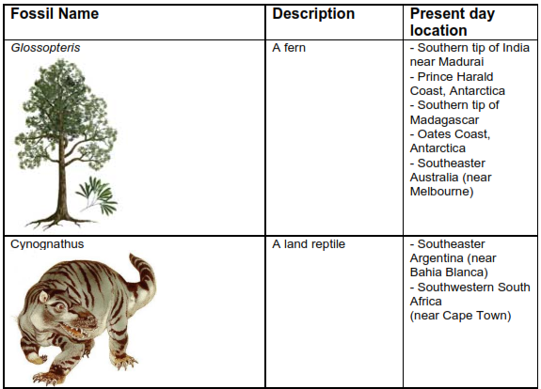
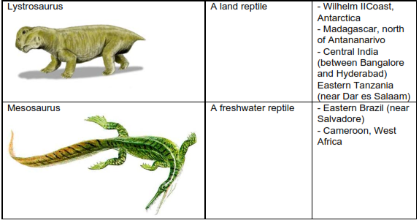

Cut this page out..

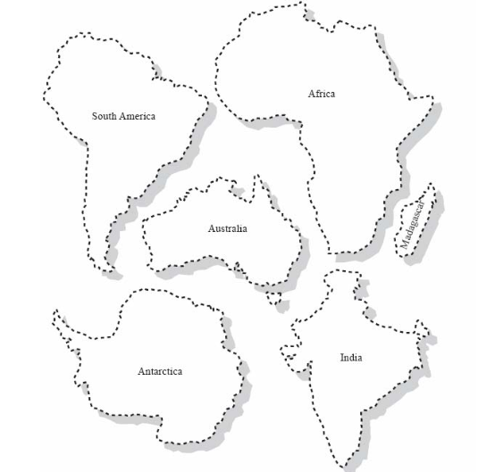

Arrange the cut out continents on this page, then colour the areas in which the four fossils were found.
Gondwanaland

- Is the presence of the same plants and animals in different countries enough evidence to
prove the existence of supercontinents?
- Can you think of any other reasons how/why these plants and animals ended up on different
countries, thousands of miles apart?

To get you thinking…

- Is the presence of the same plants and animals in different countries enough evidence to prove the existence of supercontinents?

_________________________________________________________________________________
_________________________________________________________________________________

- Can you think of any other reasons how/why these plants and animals ended up on different countries, thousands of miles apart?

_________________________________________________________________________________
_________________________________________________________________________________

Mega Fauna of Australia
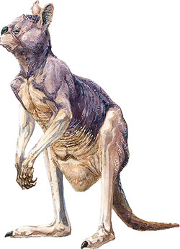

Giant short faced kangaroo lived in Australia during the Pleistocene period. It is the largest known kangaroo that ever existed, standing approximately 2 m (6.6 ft). They weighed about 230 kg.

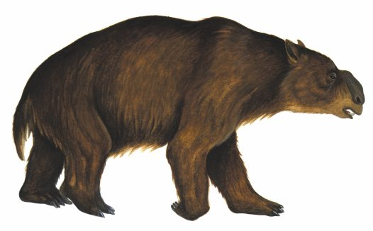
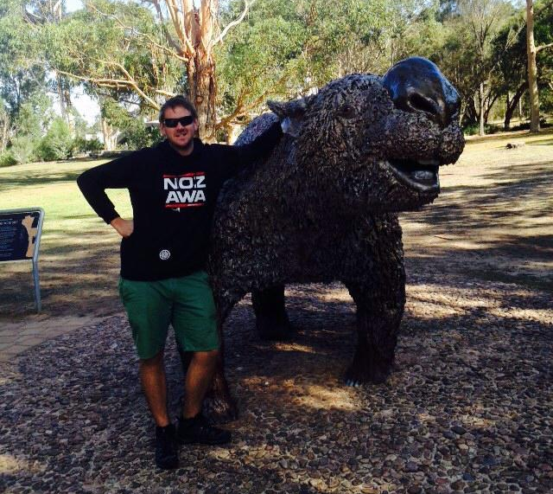
Diprotodon Approximately three meters long, two meters high at the shoulder and weighing up to two tonnes (2000kg), it resembled a giant wombat. It is the largest marsupial currently known.

- Obviously these species are much larger than those we see today in Australia. What factors do you think may have lead to their extinction?

_________________________________________________________________________________
_________________________________________________________________________________

_________________________________________________________________________________
_________________________________________________________________________________

- What characteristics do their current day descendants have that ensures their survival in the Australia of today?

_________________________________________________________________________________
_________________________________________________________________________________

_________________________________________________________________________________
_________________________________________________________________________________

Unique Australia.

- More than 80% of Australia’s flora and fauna are unique to Australia
- Of the 4000 fish species, 1700 coral species, 50 types of marine mammal and a wide range of seabirds, most marine species found in southern Australian waters occur nowhere else.
- Australia has around 10 per cent of the world’s biodiversity.
- Of the estimated 20 000 species of vascular plants found in Australia, 16 000 are found nowhere else in the world.
- Of the 378 species of mammals in Australia, more than 80 per cent are unique to Australia.
- Of the 869 types of Australian reptile, 773 are found nowhere else (endemic).

3 factors make Australian Flora and Fauna what it is today..

1 Biological isolation

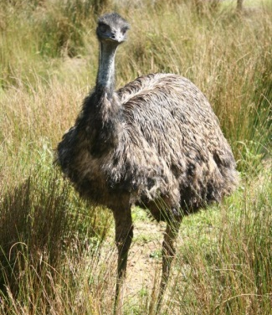
DEFINITION Australian Flora and fauna adapted to the Australian without the influence of other types of flora and fauna from other continents because Australia is an island continent (isolated). Many species adapted without influence of major predators seen on other continents.

EXAMPLE Emu – A close look at the size and physiology of an Emu's lungs has shown that they are poorly adapted for gas exchange when compared with lungs of other birds. Combined with the Emu's poor ability for oxygen intake and it's large body size, this suggests that the Emu evolved in a warm environment with few predators. If there were few predators, the Emu would not have had a selective pressure for highly efficient lungs for flight for fast escapes.

ALTERNATE EXAMPLE ______________________________
ADAPTION ___________________________________________________________________
SPECIFICALLY HOW/WHY: ______________________________________________________________________________________________________________________________________________________________________________________________________________________________________________________

2 Geological Stability

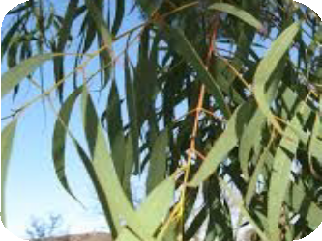
DEFINITION Due to being located in the centre of a tectonic plate without much tectonic activity (volcanoes and earthquakes) Australia is deemed to be geologically stable. This results in few new mountains being formed, soils that are nutrient poor and a landscape is very flat. Australia also has a thick continental crust and very few ‘meetings’ of continental plates (center of a tectonic plate), thus the soil is ‘nutrient poor’.

EXAMPLE Eucalyptus - With infertile dry soil, eucalyptus trees developed in Australia by improving its water retention strategies. Eucalyptus' hanging down leaves, are thinner and have high oil content to conserve water.

ALTERNATE EXAMPLE ______________________________
ADAPTION ___________________________________________________________________
SPECIFICALLY HOW/WHY: ______________________________________________________________________________________________________________________________________________________________________________________________________________________________________________________

3 Climatic Variations

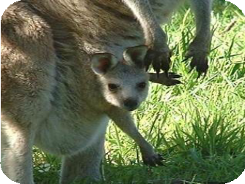
DEFINITION Australia's climate that changed from tropical and wet (rain forest during its time as part of Gondwanaland) to more arid and dry. Australia has a history of very erratic climate from El Nino to La Nina, i.e. long periods of low rainfall (8 – 10 years = drought) followed by periods of heavy rainfall (flood). Species have had to adapt to survive these harsh conditions in both extremes.

EXAMPLE Marsupials – Australian marsupials (eg: kangaroo) developed energy saving method of reproduction (the pouch) in order to conserve energy in a hot, arid Australian environment. Kangaroos have also developed a method of movement (hopping) that is highly efficient, ensuring it conserves energy in Australia’s harsh conditions.

ALTERNATE EXAMPLE ______________________________
ADAPTION ___________________________________________________________________
SPECIFICALLY HOW/WHY: ______________________________________________________________________________________________________________________________________________________________________________________________________________________________________________________

PRACTICE QUESTION 1

The uniqueness of the Australian environment has been shaped by three main characteristics. Name these three characteristics, provide a detailed description of how they have shaped the Australian environment and give an example to support your explanation.

___________________________________________________________________________
___________________________________________________________________________
___________________________________________________________________________
___________________________________________________________________________
3 marks

___________________________________________________________________________
___________________________________________________________________________
___________________________________________________________________________
___________________________________________________________________________
3 marks

___________________________________________________________________________
___________________________________________________________________________
___________________________________________________________________________
___________________________________________________________________________
3 marks

