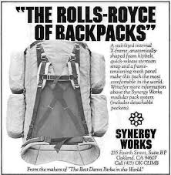
Technology Presentation
Your job is to choose a recreational activity that you feel has evolved greatly over the past 100 years.
Create a presentation detailing the following:
- Detail the changes over time in equipment and interactions (History)
- Analyse the benefits of the advancements on interactions and perceptions with the environment
- Explore the negative impacts on the environment due to these advancements
- Evaluate how this has changed participants relationships with the environments used for this activity (perceptions/interactions/impacts)
- Suggest an idea that would change equipment and encourage positive interactions with the environment

Technology Presentation
Your job is to choose a recreational activity that you feel has evolved greatly over the past 100 years.
Create a presentation detailing the following:
- Detail the changes over time in equipment and interactions (History)
- Analyse the benefits of the advancements on interactions and perceptions with the environment
- Explore the negative impacts on the environment due to these advancements
- Evaluate how this has changed participants relationships with the environments used for this activity (perceptions/interactions/impacts)
- Suggest an idea that would change equipment and encourage positive interactions with the environment

