# Tony Yao - Professional Rock Climber

<http://www.hotshotfitness.com/tony_yao.html>

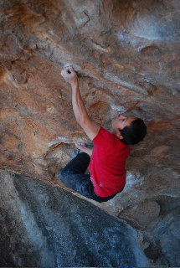Hotshot Fitness caught up with Tony "T-Nut" Yao while he was kicking back in the mountain mecca of Boulder, Colorado. This rock rat hails from the Lonestar state, and loves two things: his wife Jen, and rock climbing. By day, he's a route setter at theBoulder Rock Club*,*an indoor rock gym in Boulder. He also coaches the BRC's junior climbing team, and serves as a personal climbing trainer to newbies and rope guns (experts) alike. As if that wasn't cool enough, he burns all his vacation time hopping around the globe, throwing up first ascents withLa Sportiva's ridiculously talented Climbing Team. At 5'5", he's not the biggest guy on the mountain, but he's arguably the toughest. How tough? While climbing a route in Rifle, Colorado,***he literally took a fall so gnarly it ripped his finger off.***When we heard that bit of folklore, we knew we had to talk.

**HF: How did you get into climbing?**  
**TY:** I just finished my freshman year in college, and I went with a buddy to the local climbing gym. We had no idea what we were doing. Fortunately for us, the gym had Petzl GriGri's attached to the floors and gave us a five minute tutorial. When I got back from summer break, another friend had started climbing, and I soon bought my very own climbing shoes and harness. The rest, as they say, is history.

**HF: What keeps you amped up and motivated to keep pushing your limits every day?**  
**TY:**The thing about rock climbing is there is always room for improvement. Even if I feel strong, I want to feel stronger. Even if I send my recent project, I am looking for the next one. I am planning my training around road trips. I am planning my road trips a year out. It's a endless cycle of getting fit, so you don't suck when you are in exotic places like Kalymnos, Greece, Thailand or Barloche, Argentina.

**HF: For those of us who have never climbed - how exactly do you train for it?**  
**TY:**Especially for beginners, the best way to train for climbing is simply to climb. When you first start rock climbing, it's comparable to a baby taking his/her first steps. The sensation can feel completely foreign, and it can feel really, really hard. So the best training for beginner climbers is to get the awkward feeling out of your system. Just climb! Watch the movement of experienced climbers. Watch how fluid they move. Before you know it, you will be moving smoothly and fluidly.

**HF: I don't care what anyone says: nobody is completely unafraid of heights. It's got to get scary sometimes - how do you cope with that fear?**  
**TY:**Again it's all about rational and irrational fears. You over compensate for instinctual fear with logical talks inside your head. It doesn't always work, but hopefully you can win the battle in your head. Climbing on the same routes also allows one to get more comfortable with falling. Your body gets use to the stressful movements, and before long all you are thinking about is the climbing and not the falling part.

**HF: What's the biggest misconception people have about what makes a good climber?**  
**TY:** People always think if you have big muscles you can climb really well. I have spent the last fifteen years trying to lose muscle mass! Strength to weight ratio is the optimum balance to rock climbing. You have to be strong AND light! People also do not realize the enormous amount of importance of using your legs and flexibility in climbing. If you can utilize your feet more, you are taking more weight off your arms. My wife can not do more than 5 pull ups, but she can climb 5.12+. People also think the taller you are the better you will be. Well I've been climbing a long time, but I have rarely seen a NBA-sized rock climber. It comes back to that strength to weight ratio and leverage. At some point, one can have too long of limbs. That's why gymnasts are typically small and light. Climbing is the same way.

**HF: Endurance is also vital for firefighters. Working 16 hour shifts, day after day is draining - just like pulling your body up a vertical rock wall. What do climbers do to buildup their endurance?**  
**TY:**Most climbers do a lot of cross training. I will run four to five times a week besides my climbing schedule. Climbing days are also long and can be arduous. At the end of the day, it is about how far can you break down your muscles, so they can rebuild and become stronger for the next training session.

**HF: What are your thoughts on Yoga? Mystic nonsense or daily ritual?**  
**TY:**I cannot stress the importance of active flexibility to rock climbing. Yoga is a great tool for flexibility. The ability to focus in yoga can also translate to rock climbing. The late Wolfgang Gullich always said rock climbing is 90% mental and only 10% physical! I absolutely agree.

***Questions***(To be done in your note book)

1. What does this rock-climber see as important?
2. How do they deal with obstacles in life and in their sport?
3. What motivated him to start climbing when he was younger?
4. Does fear affect him? Explain.
5. What motivates them to continue rock-climbing?
6. How does this climber’s motivations compare to the other climber studied by your classmates?

# 'Intrinsic': New Video and Interview Share Climber Chris Sharma's Life in Spain

12/03/2012 <http://www.rei.com/share/rei-blog/2012/12/chris-sharma-intrinsic.html>

**REI: What is the biggest thing you’ve learned about yourself because of climbing?**

CS: I’ve been climbing for most of my life and, looking back, climbing has been woven into almost all of my experiences.  What’s so great about climbing is that it’s not only a sport but a lifestyle. Of course, the amazing activity of climbing rocks is at the center of it all, but I’d say the friends you meet along the way, the amazing places we get to visit, being in a foreign country and trying to communicate in a different language are all things that have equally made climbing so enriching for me.

However, going back to the basics: Working on these extremely challenging routes, has forced me to confront my fears and weaknesses, to dig deep and not give up even in super frustrating moments.

Even though climbing is much more than just a sport, the athletic side of it is fascinating. To discipline your body and mind to do what you tell it to do, is an amazing feeling when it all comes together. These are things that come naturally up to a certain point and then the only way is hard work and to be 100% committed to go beyond our comfort zone. Some prefer the structure of a regimented training program. For me, however, the climbs that I strive to achieve are the structure, the program and the goal all in one.

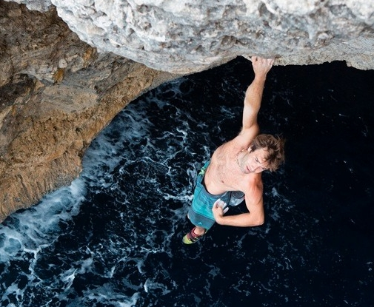 **REI: You talk about not forcing yourself to go climbing because you feel like you need to go, but rather following your motivation to climb so that it’s genuine. Has it always been that way for you?**

CS: I think I’ve always had a bit of a laid back, intuitive and spontaneous approach to climbing. Climbing is such a personal thing, and that’s one of the things I loved about it when I was just getting started. Everyone has their own way, and whatever works for you is your way. Of course, there are times when you have to work really hard, and it’s a struggle and it’s not easy. To take our climbing to another level, we have to try harder than we've ever tried before. But at the same time I think it’s really important to not lose sight of why we are doing it (that we are passionately in love with climbing). I’ve seen many people turn climbing into this frustrating, anguishing thing, where there is no joy in the process (and in climbing, the process is what it’s all about).

The moments of success in climbing are really brief when we get to the top of our project and celebrate, whereas the moments of slogging through the trenches are the majority. It’s not always easy to see this, but if we lose sight of it then climbing stops being enjoyable, and we won’t be climbing our best either.

Climbing is a lifelong pursuit, and in that way I think it’s normal to not always be 100% motivated. It’s important to recognize that and not get frustrated. For me, the most important feeling is to be motivated and inspired, and the rest always happens naturally. Sometimes the motivation isn’t there, and we have to be patient and not force things. Sometimes taking a step back and taking a breath of fresh air helps us see clearer why we love climbing so much and reaffirms our commitment and motivation in our projects.

***Questions***(To be done in your note book)

1. What does this rock-climber see as important?
2. How do they deal with obstacles in life and in their sport?
3. What motivated him to start climbing when he was younger?
4. Does fear affect him? Explain.
5. What motivates them to continue rock-climbing?
6. How does this climber’s motivations compare to the other climber studied by your classmates?