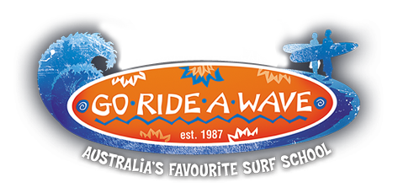

About Go Ride A Wave..
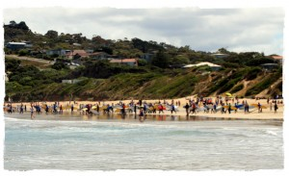
Our business was established in 1987 in Anglesea, Victoria and now takes care of more than 50,000 customers every year from multiple locations along the Great Ocean Road – Wye River, Lorne, Anglesea, Torquay and Ocean Grove.
In addition to the Victorian Surf Coast, we now operate in Surfers Paradise, Broadbeach and at Northcliffe on the Gold Coast and Noosa Heads on the Sunshine Coast.
We are passionate about Go Ride A Wave, and it is our great pleasure to share the joys of surfing and other outdoor recreation activities with our valued customers.
Go Ride A Wave helped to create the surf school industry standards and is a member of the Surfing Australia surf schools. We take very seriously our obligation to provide a safe and enjoyable experience for our clients, as well as protecting the environment and other users, while we conduct our activities.
Today we provide a diverse range of outdoor recreational activities including surfing, bodyboarding, surf life-saving, surf carnivals, surf safety, lifeguarding, sit on top kayaking, “Surfgroms”, stand up paddle boarding (SUP) and corporate and team building activities.

