Environmental Issues in Australia Research task
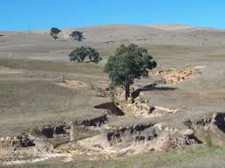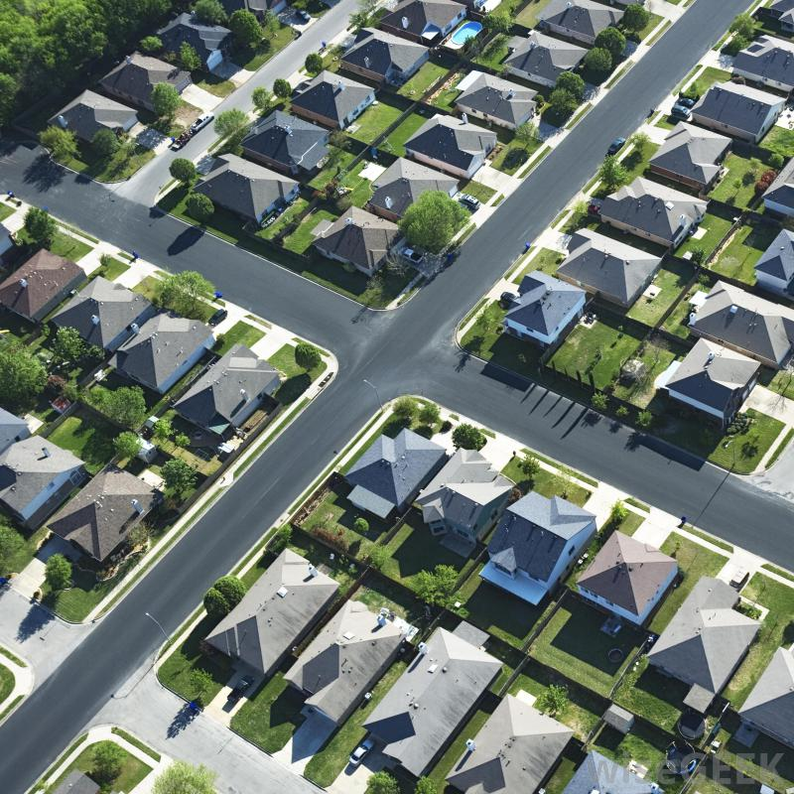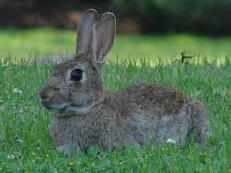

Key Knowledge Point: the potential impact on society and outdoor environments of land degradation, introduced species, climate change, urbanisation and other significant threats

Our Task as a class is to research the Potential Impact on society and outdoor environments from the following Human impacts-
- Land Degradation
- Introduced Species
- Climate Change
- Urbanisation
- Over Population
- Deforestation/vegetation loss
- Dams and changing of water courses/loss of river flows

We will break into groups of 3-4 students and research a potential impact each. We will become an expert in one of the areas and develop a fact file that will be collated and have for our own resources for the upcoming SAC and Exams.

Your fact file (Simple word document including pictures and photos) must contain the following as a minimum-
- Introduction to your topic, what is the issue and why is it occurring?
- Potential Impact on individuals-
  - How will your issue affect the values individuals have for nature?
  - Use Statistics and Evidence to back up your information.
- Potential Impact on Society-
  - How will your issue affect society and our way of life in the future?
  - Use Statistics and Evidence to back up your information.
- Potential Impact on Outdoor Environments-
  - How is your issue affecting Outdoor Environments? (Not just for the use of Humans).
  - Use Statistics and Evidence to back up your information.
- Reducing or Fixing the Problem-
  - List and Explain changes that can be made to reduce or fix the problem.
It is important that you use your time wisely as we are developing resources for the whole class. If one group fails to put in we will have to go over this section again. Essentially you would be letting your classmates down with lack of effort.

