Relationships with outdoor environments reflected in different forms of conservation, recreation, primary industries, and tourism practices

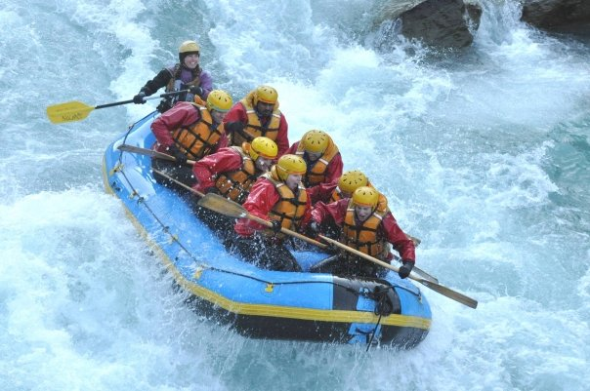

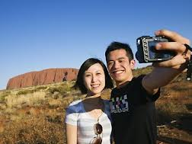
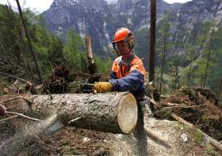

Contemporary societal relationships with outdoor environments reflected in different forms of Conservation, recreation, primary industries, and tourism practices

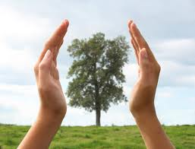
Conservation means…
“The protection and enhancement of the environment”
We now know that Australian conservation began in the early 1800’s with groups like the Field Naturalist of Victoria, and become popular in the 1970’s when people began to realise the huge impact our industries where having on the environment. In short, conservation is people working to protect and restore natural environments. eg. Research into the state of the natural environments, erosion, salinity and feral control, management of tracks and water catchments. Conservation is now accepted of being of greater importance and people therefore are more likely to take part in conservation activities then in colonial times.
Impacts of conservation are thought to be positive as the definition would show.

Task:
- In your work books write down as many impacts of conservation as you can think of (10 minimum).
- Google some of the different conservation societies/actions/groups currently in Australia. For two of these, detail what do they do and how this achieves the definition of conservation.
- How might these groups change Australian people’s relationships with the areas being conserved - 200words (Think of perceptions, interactions and impacts).

Contemporary societal relationships with outdoor environments reflected in different forms of conservation, Recreation, primary industries, and tourism practices
Recreation…..
Koori’s spent less than five hours as a day working/hunting whereas colonists spend all the daylight hours working and therefore they had little time for activities such as horse riding and picnicking. These days people have far more time for recreation, and more choice; as a result society has become more isolated from nature (air conditioning, cars, internet, gaming), and therefore needs to travel further to gain access to outdoors recreation pursuits like:
Mountain bike ride, hiking, surfing, climbing, kayaking, skiing and bushwalking. Other more passive recreation could be just relaxation, bird-watching, and fishing.
People become involved in recreational activities for many reasons including, fitness and health, relaxation, connecting with nature. Positive impacts can include (Note these in your workbooks):
- Improved physical health.
- Break from the stresses of modern life.
- Stronger connection with nature.
- Improved mental health
- Demand for more parks and conservation.
- Brings much needed revenue and jobs to smaller towns such as alpine and coastal areas.

Negative impacts can include:
- More injuries in often hard to reach places.
- More people means greater impacts such a rubbish, erosion of tracks, bushfires, decreased habitat.
- Increased costs of land management.
- With greater management comes less adventure

Task:
- What would you see as positive impacts of your favourite recreational activity? (List 4 different to those detailed above)
- Choose a recreational activity you enjoy and detail the negative impacts of it.
- Using the impacts you have detailed (Both positive and negative) analyse whether the activity of your choice is good for society and the environment – 200 words.
- Vic government has removed gate entry to nearly all parks to encourage Victorians to visit natural environments. Why do you think this is and what’s the pay-off?
- How do recreational activities change people’s perceptions, interactions and impacts on the environment?
Contemporary societal relationships with outdoor environments reflected in different forms of conservation, recreation, Primary industries, and tourism practices

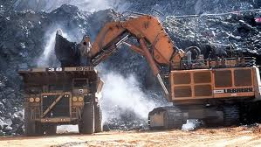
Includes most types of farming, logging, and mining.
Basically the natural environment is used as a resource for profit, whether it is sold domestically or exported. Society placed laws to restrict the full exploitation of our natural resources such as minerals, flora and fauna. While they all are potentially renewable (with the exception of minerals) they are rarely sustainable. Primary industry provides essential goods and basic needs however this always comes at a cost. At the time of the first settlers ‘the costs’ were of no concern, however more recently greater restrictions, laws, guidelines and licences restrict overharvesting and total exploitation.

Task:

Research the following industries;
- Cattle grazing
- Logging
- Mining
- Fishing
- Crop farming

For each of these industries detail the following:
- What this industry is and what they do
- Why as a society we require this primary industry
- Positive impacts they have on the environment
- Negative impacts they have on the environment

Now detail how overall primary industries have changed the way we interact and impact with the environments involved.

Contemporary societal relationships with outdoor environments reflected in different forms of conservation, recreation, primary industries, and Tourism practices

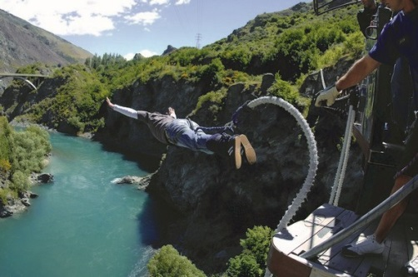
Tourism is….
This can come in many forms but tourism is generally known as travel for recreational, leisure or business purposes.
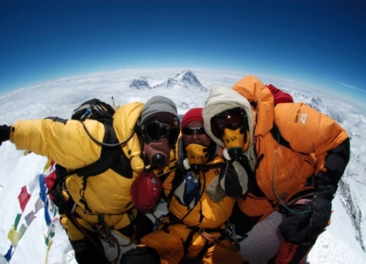
Australian financially benefits greatly from both domestic and international tourists. The greatest benefit is from overseas where the $ boosts are economy and provides millions of jobs.
Tourism like all other industries has it’s own set of both positive and negative impacts on the environment and society, which for the most part are obvious.
Tourism almost always use the environment as a resource. Either as a focally point or in more of a ‘playground’ for recreational activities. Features the environment that the tourism activity uses in their advertising campaigns. They also always feature the activity in the best weather conditions for that activity.
Tourism can come in the following forms
- Mass Tourism – think of retirees and bus trips.
- Wine Tourism – think of small groups of something wine snob staggering around in minibuses
- Adventure Tourism – risky activities in remote and sometimes dangerous places.
- Eco-Tourism –responsible low impact tourism. This is often to sensitive or pristine areas designed to educate as well as entertain. A % of $ usually goes to conservation the area. Eg ocean kayaking, hiking, snorkelling.
- Wildlife Tourism – is specifically observing animals in their habitat. This is closely related to eco-tourism and has many of the same benefits. Examples include shark cage diving, whale watching, and African wildlife safaris.

Task:

Research the above forms of tourism in Australia.

For each of these detail the following:
- What this is and what they do
- Why Australians generally undertake this practice
- Positive impacts they have on the environment
- Negative impacts they have on the environment

Now detail how overall tourism practices have changed the way a specific group perceive, interact and impact with the environments involved.

