Alpine cattle grazing and the Media
A quick introduction to the issue
Unusually for an Australian National Park, for much of the Alpine National Park’s history agricultural activity was conducted in the park, with quotas of cattle allowed to graze on the High Plains during summer. Australia’s alpine area was first used for grazing around the 1840s. Concerns about the environmental effects led various governments to remove grazing from parts of the alps over the next century. Grazing was temporarily halted in Mount Buffalo National Park in the 1920s and stopped altogether in 1952. Cattle were taken out of Kosciuszko National Park in NSW during the 1950s and 1960s due to concerns about the effect of grazing on water quality for the Snowy River Scheme. Grazing was also removed from Mounts Feathertop, Hotham and Bogong around this time, from around Mount Howitt in the 1980s, and from the northern Bogong High Plains, the Bluff and part of Davies Plains in the early 1990s, leaving about one third of the Alpine National Park – over 200,000 hectares – available for grazing. In 2004, the Victorian State Government made the decision that cattle grazing would no longer be permitted in this remaining area of the Alpine National Park. Grazing is still permitted in alpine State Forest areas.
When the Victorian state government announced plans to end this grazing, the then federal government, floated the idea of using national cultural heritage powers (on the basis of the cultural place given to the mountain cattleman, notably through ‘The Man from Snowy River’ history) to override the state decision. They failed in their mission and Alpine cattle grazing was banned.
More recently Victorian Premier, Ted Baileu, attempted to re-open the park to mountain cattlemen, with the idea that their grazing would reduce the risk of fires in the area (without consideration of the environmental damage this practice causes). He also failed to overturn this due to outrage from environmental groups and the federal government.

Now look at the following media articles and analyse how they are portraying this natural environment but be aware that media companies often use strong opinion pieces to simply sell papers.
‘A lot of bull in this title’
Weekly Times Now - February 2, 2011
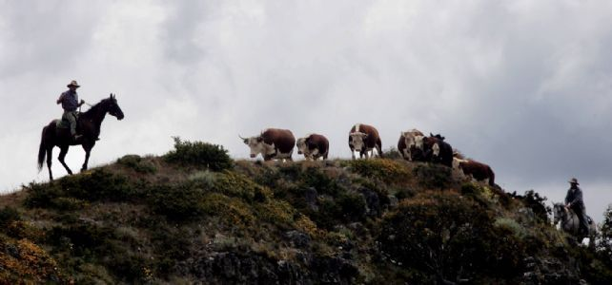
THE Victorian Government's bid to re-brand alpine grazing as a beneficial practice took a new twist this week.
Victorian bureaucrats will no longer use the term "mountain cattlemen" to describe the tough bushmen who inspired the legend of the Man from Snowy River.
The Department of Sustainability and Environment communications staff have given mountain cattlemen a new title - Fuel Reduction Service Providers.
What's next? Are they going to call cattle "grazing units".

Copy the following questions into your workbooks and answer them:
- What does this article suggest is happening?
- What words give you an understanding of this author’s stand point?
- How does renaming the cattlemen change this situation?
- The headline shows a strong opinion on this issue that can sell papers. Do you think this would persuade readers? Why/Why not?

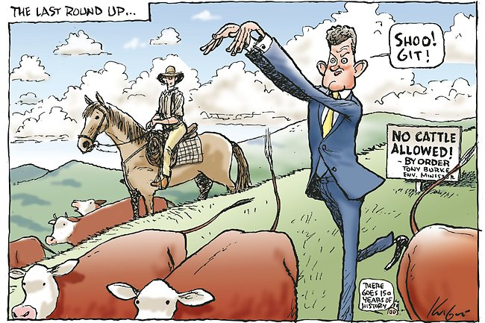
1. What does this image suggest is happening?
2. What is the view of the artist?
3. Does this image portray the banning of Alpine cattle grazing as a positive of negative thing?
4. Is imagery a stronger conveyer of opinions for you than written text?

Image: The Age Newspaper, Mark Knight (Cartoonist)

